Work station on RHEL -->

step 1 ) Install aws cli

-----------------------------------------------------------------------------

curl "https://s3.amazonaws.com/aws-cli/awscli-bundle.zip" -o "awscli-bundle.zip"

unzip awscli-bundle.zip

sudo ./awscli-bundle/install -i /usr/local/aws -b /usr/local/bin/aws

vi ~/.bash_profile (set path for aws)

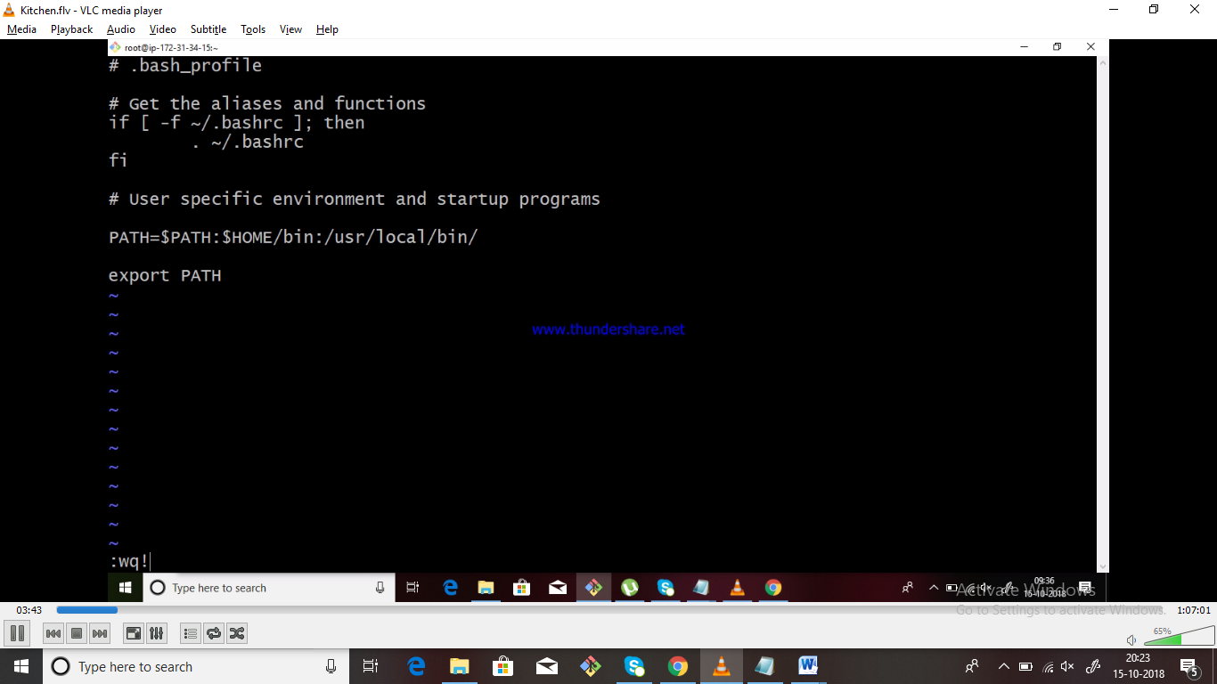

Source ~/.bash_profile

aws --version

**copy the IAM access key and secret key from aws console.**

aws configure

enter the access keys

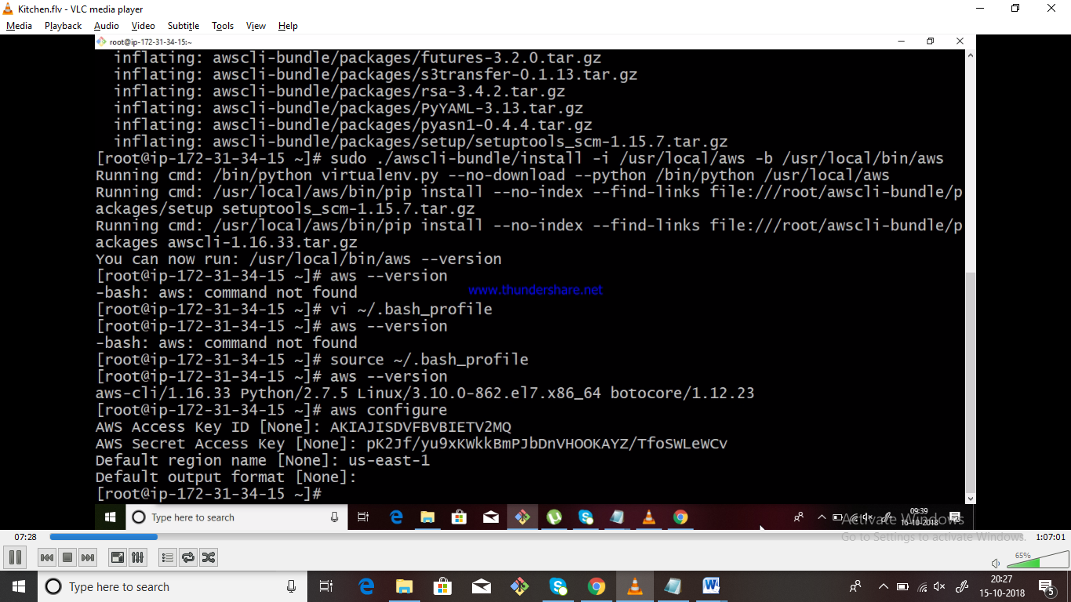

step 2 ) navigate to your cookbook

---------------------------------------------------------------------------------

ls -lart will list the .kitchen.yml

modify as below to spiin up ec2 instance.

Vi .kitchen.yml

.kitchen.yml

==========================================================================

---

driver:

name: ec2

aws_ssh_key_id: 31stAug_

security_group_ids: ["sg-00e36b085f728ab14"]

region: ap-south-1

availability_zone: a

require_chef_omnibus: true

subnet_id: subnet-f0695299

instance_type: m4.large

associate_public_ip: true

provisioner:

name: chef_zero

platforms:

- name: ubuntu-16.04

driver:

image_id: ami-ffc3e790

block_device_mappings:

- device_name: /dev/sda1

ebs:

volume_size: 50

delete_on_termination: true

transport:

ssh_key: /root/31stAug_.pem # (provide your PEM file path)

connection_timeout: 300

connection_retries: 5

username: ubuntu

suites:

- name: default

run_list:

- recipe[mykitchencb::install_apache2]

=====================================================================================

Kitchen create (it will create the instance in aws console)

kitchen converge

kitchen verify

kitchen destroy (it will destroy the instance)

connect to Ubuntu instance & check apache2 is installed or not